Lift chart is used to show the lift data with respect to ideal data.

It has lot of options to customize the chart as per our needs.

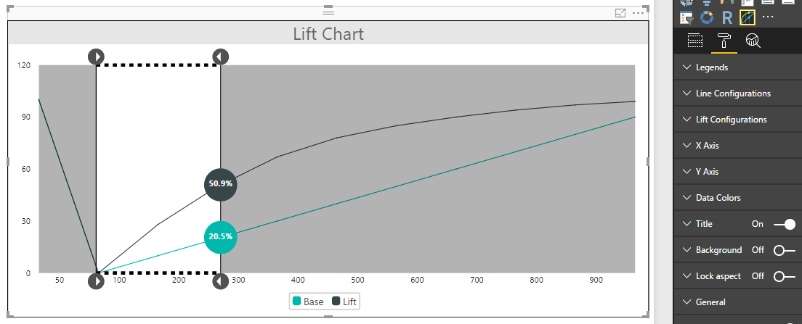

Configurations:

1. Legends:
   1. Enable: To enable legends
   2. Enable click: To make legend clickable for showing/hiding some values by clicking on legends
2. Line Configurations:
   1. Step Line: To enable or disable step line  
      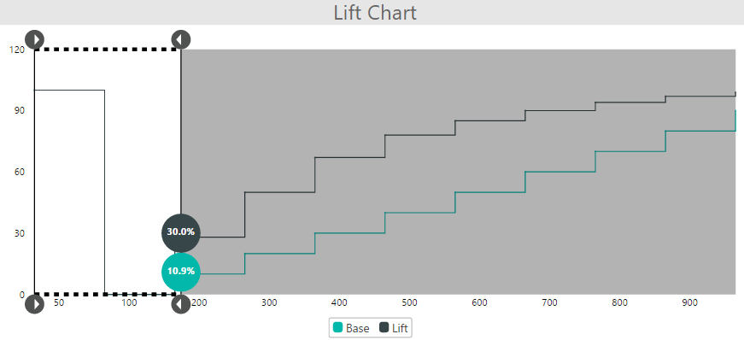
   2. Marker: To enable or disable marker  
      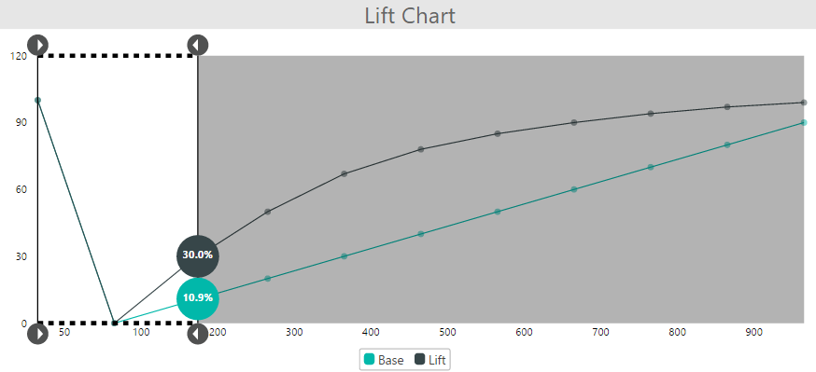
   3. Marker Width: To set marker size
   4. Line Width: To set ideal and lift line width  
      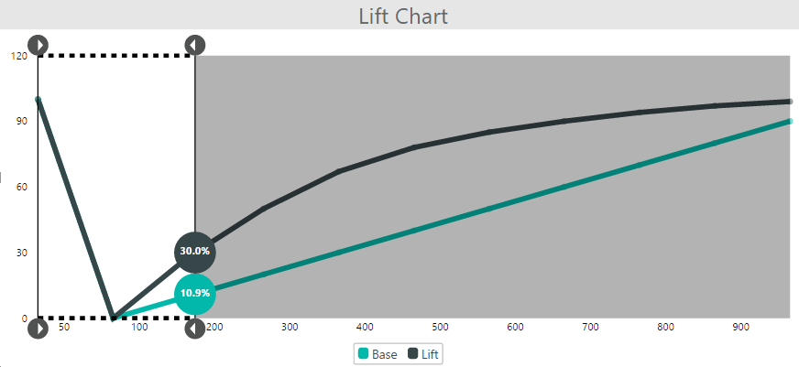
3. Lift Configurations:
   1. Drag Line Color: To set color of selected window line  
      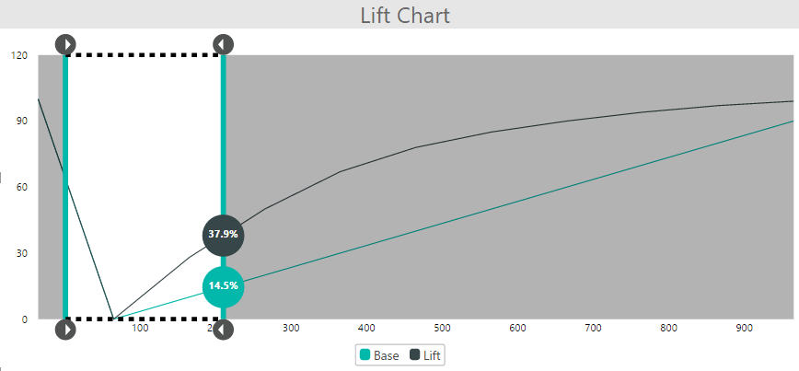
   2. Drag Line Width: To set width of selected window line
   3. Bubble Color: To set font color of bubble  
      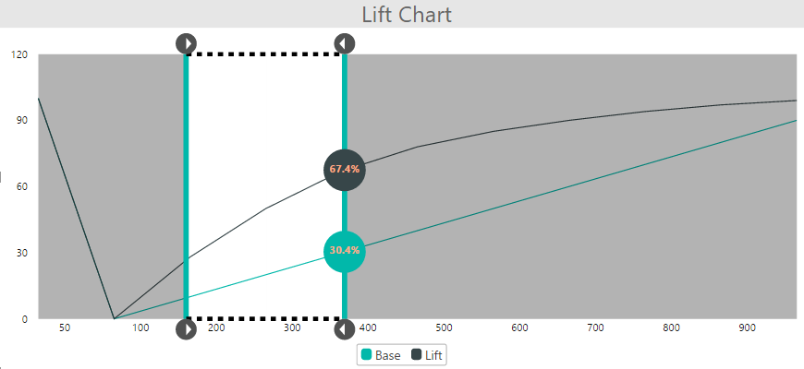
   4. Bubble Size: To set font size of bubble
4. X Axis:
   1. Enable Labels: To show/hide labels on X Axis
   2. Font Size: To set font size of X Axis labels
   3. Grid Line Color: To set grid line color on X Axis  
      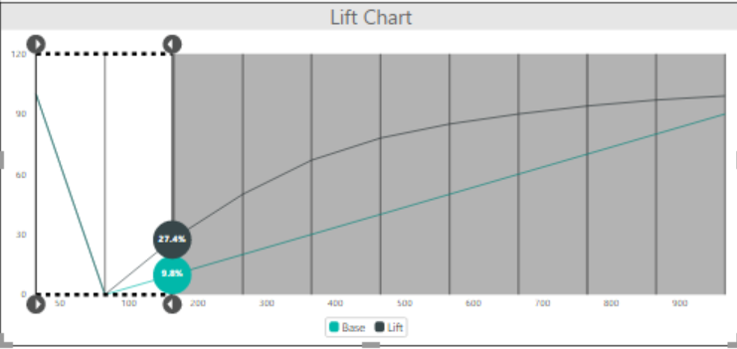
   4. Grid Line Width: To set width of grid line on X Axis
5. Y Axis:
   1. Enable Labels: To show/hide labels on Y Axis
   2. Font Size: To set font size of Y Axis labels
   3. Grid Line Color: To set grid line color on Y Axis   
      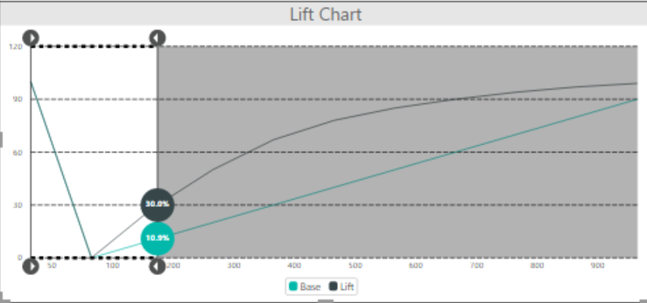
   4. Grid Line Width: To set width of grid line on Y Axis
6. Data Colors: To set colors of lift and ideal lines